Fourth Annual
Middle and Junior High School Teacher Institute:
August 12, 13 and 14, 2015

Master your knowledge and skills with iCivics

Sponsored by the U.S. District Court, Western District of Washington and the
Seattle University School of Law
www.wawd.uscourts.gov/educators-media/educational-resources

Absolutely. I already have begun to recommend to teachers. Besides being such an excellent learning experience, the iCivics curriculum would help all the students of my school understand some law and how government works and also learn how to be good US citizens, have productive lives, and not end up in federal court themselves. Lol. Middle School Teacher, 2014.

The jury selection simulation was out of this world. To be able to conduct this simulation in a Federal Courtroom with a sitting Federal Judge and actual attorneys was the ultimate highlight. Vicky Webb, Ridgetop Junior High School, 2014.

Yes! First of all the quality of instruction was very high and you treated us like educated professionals. I felt very honored. I felt respected intellectually. The materials are immediately usable…. And the food and accommodations were particularly great! Middle School Teacher, 2014.

iCivics curriculum will become the thread that connects my year-long US History curriculum. –Sam Olson, Salmon Bay Middle School, 2014.

The U.S. District Court for the Western District of Washington in collaboration with the Seattle University School of Law is offering middle and junior high school teachers a unique opportunity to become proficient with using the free iCivics curriculum in the classroom. The program launched by Justice Sandra Day O’Connor is built around computer games that teach important civic content while students have fun. See www.iCivics.org.

This 3-day institute will help teachers become proficient in the games and lesson plans, as well as learn more in-depth content on the federal judiciary, the U.S. Constitution, branches of government, and civil rights. Washington State Supreme Court Justice Mary Fairhurst and Chief Magistrate Judge Mary Alice Theiler will contrast how state courts differ from federal courts. Judges who hear the cases you read about in the news, with long-term law-related education expert and iCivics Director for Washington Margaret Fisher, will prepare you to implement the iCivics lessons immediately in the classroom.

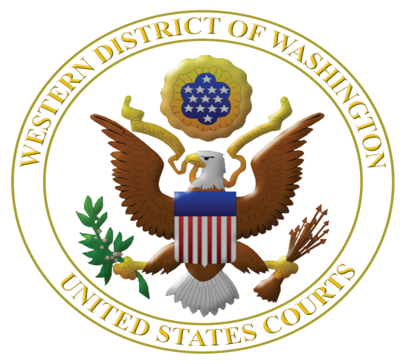

iCivics Institute for Middle and Junior High School Teachers

Eligible applicants: Thirty middle and junior high school teachers teaching in any of 19 western counties of Washington* who did not participate in a prior iCivics Institute.

Dates and times: Program starts at 8 a.m. on August 12 and ends on August 14 at 3 p.m. A group dinner will be hosted on Thursday, August 13. Teachers will be provided single rooms at the historic Mayflower Park Hotel for the nights of August 11, 12 and 13.

Institute Location: U.S. District Court, 700 Stewart St., 19th floor, Seattle, WA 98101.

Clock hours: 20 clock hours pending, credit hours paid by teacher.

Cost: No charge, meals, mileage, parking, and hotel rooms provided.

Registration: Rolling registration.

Selection: Based on time of application and geographic diversity.

More information: Margaret Fisher, Seattle University School of Law, fisherm2@seattleu.edu or 206-501-7963.

Please apply early and send your completed application as soon as possible to:

Margaret E. Fisher
Distinguished Practitioner in Residence
Seattle University School of Law
P. O. Box 222000
Seattle, WA 98122 or send by email to: fisherm2@seattleu.edu

*Counties in the Western District of Washington are: Clallam, Clark, Cowlitz, Grays Harbor, Island, Jefferson, King, Kitsap, Lewis, Mason, Pacific, Pierce, San Juan, Skagit, Skamania, Snohomish, Thurston, Wahkiakum, and Whatcom.

APPLICATION to iCivics Institute 2015

Name: _______________________________________________________________

Name of Middle or Junior High School: _____________________________________

School Dist./Employer: ______________ County School Located: _______________

School Address: _______________________________________________________

City: ______________, WA Zip: ______

Work Email Address: ___________________________________________________
Preferred during school year: ____ Yes ____ No; During summer 2015: ____ Yes ____ No

Personal Email Address: __________________________________________________
Preferred during school year: ____ Yes ____ No; During summer 2015: ____ Yes ____ No

Washington Teaching License #: _________________________________

Home Mailing Address: ________________________City: _____________, WA Zip: ________

Phone Numbers: Work ______________ Home _______________ Cell ________________

Provide a brief statement of intent – no more than 300 words – as to how you will use the iCivics Institute experience in your teaching assignment and share your experience with teaching colleagues.

By submitting this application, I certify that (please initial):

I will commit to attending all three days of the iCivics Teacher Institute. NOTE: Absent
an emergency, teachers will not be excused from full participation in all sessions.

And

I have notified my principal of my application to this Institute. Name of Principal or
Administrator: _____________________________________________________

Please send your completed application as soon as possible to:

Margaret E. Fisher
Distinguished Practitioner in Residence
Seattle University School of Law
P. O. Box 222000
Seattle, WA 98122 or send by email to: fisherm2@seattleu.edu

