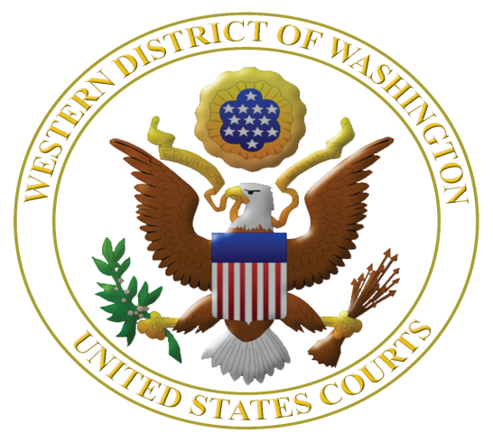
Fourth Annual

Judicial Institute for High School Teachers: July 22, 23 and 24, 2015

Featuring Mary Beth Tinker of Tinker v. Des Moines School District

Learn More about the U.S. Constitution, Federal Judiciary, Civil Rights, and Federal Criminal Law
www.wawd.uscourts.gov/educators-media/educational-resources

By far the most beneficial and interesting professional development opportunity I have experienced in my 15 years of teaching. The practical aspect of experiencing the information "first hand" made this a fabulous three days...Don Wilson, Everett High School, 2014.

The collegiality and knowledge available to us at this program is top notch. In over 20 years of teaching, this is one of the BEST professional development programs I've attended. May Wong, Kentridge High School, 2014.

This was undoubtedly the best civic education experience I've ever had. I can't wait to incorporate everything I've learned into my future teaching. Dori Wuepper Bothell High School 2014.

The Institute offers a close-up look at the US Courts and a rare chance for Social Studies teachers to interact with federal judges and experts. It's intimate and fun and builds professional camaraderie, too. David Ruby, Mountlake Terrace High School, 2014.

The U.S. District Court for the Western District of Washington in collaboration with the Seattle University School of Law is offering high school teachers a unique opportunity to learn about the U.S. Constitution, federal judiciary, and issues of civil rights, federal-state courts, and federal criminal law. This year the program features Mary Beth Tinker, plaintiff in Tinker v. Des Moines School District (1969), in which the U.S. Supreme Court ruled that public school students do not shed their free speech rights at the school house door.

Judges who hear the cases you read about in the news will be faculty along with long-term law-related education expert Margaret Fisher to help translate this content into lessons immediately usable in the classroom.

Judicial Institute for High School Teachers

July 22, 23 and 24, 2015

Sponsored by the U.S. District Court, Western District of Washington and the
Seattle University School of Law

Eligible applicants: Thirty high school teachers teaching in any of 19 western counties of Washington* who did not participate in a prior Judicial Institute for High School Teachers.

Dates and times: Program starts at 8 a.m. on July 22 and ends on July 24 at 3 p.m. A group dinner is schedule for Thursday, July 25. Teachers will be provided single-occupancy rooms at the nearby downtown historic Mayflower Hotel for the nights of July 21, 22 and 23.

Judicial Institute Location: U.S. District Court, 700 Stewart St., 19th floor, Seattle, WA 98101.

Clock hours: 20.5 clock hours pending, credit hours paid by teacher.

Cost: No charge, meals, mileage, parking, and hotel rooms provided.

Registration: Rolling registration until 30 slots are filled.

Selection: Based on time of application and geographic diversity.

More information: Margaret Fisher, Seattle University School of Law, fisherm2@seattleu.edu or 206-501-7963.

Please apply early and send your completed application as soon as possible to:

Margaret E. Fisher
Distinguished Practitioner in Residence
Seattle University School of Law
P. O. Box 222000
Seattle, WA 98122 or send by email to: fisherm2@seattleu.edu

*Counties in the Western District of Washington are: Clallam, Clark, Cowlitz, Grays Harbor, Island, Jefferson, King, Kitsap, Lewis, Mason, Pacific, Pierce, San Juan, Skagit, Skamania, Snohomish, Thurston, Wahkiakum, and Whatcom.

APPLICATION to the Judicial Institute for High School Teachers 2015

Name: ___________________________________________________________________

Name of High School: ______________________________________________________

School Dist./Employer: ______________ County School Located: ___________________

School Address: ___________________________________________________________

City: ______________, WA Zip: ______

Work Email Address: ___________________________________________________
Preferred during school year: ____ Yes ____ No; During summer 2015: ____ Yes ____ No

Personal Email Address: __________________________________________________
Preferred during school year: ____ Yes ____ No; During summer 2015: ____ Yes ____ No

Washington Teaching License #: ______________________________________________

Home Mailing Address: ________________________City: _____________, WA Zip: ________

Phone Numbers: Work ______________ Home _______________ Cell _______________

Provide a brief statement of intent – no more than 300 words – as to how you will use the Judicial Institute experience in your teaching assignment and share your experience with teaching colleagues.

By submitting this application, I certify that (please initial):

I will commit to attending all sessions on all three days of the Judicial Institute. NOTE: Absent an emergency, teachers will not be excused from full participation in all sessions.

And

I have notified my principal of my application to this Institute. Name of Principal or
Administrator: _____________________________________________________

Please send your completed application as soon as possible to:

Margaret E. Fisher
Distinguished Practitioner in Residence
Seattle University School of Law
P. O. Box 222000
Seattle, WA 98122 or send by email to: fisherm2@seattleu.edu

