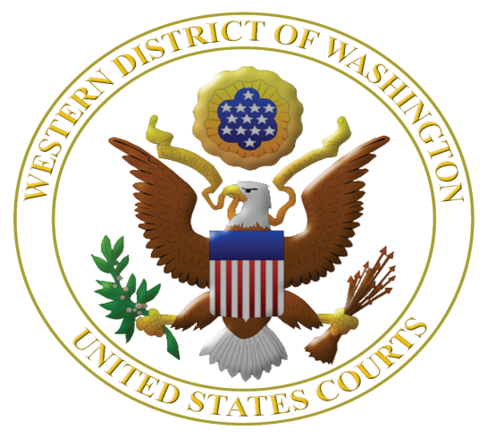
Virtual Fourteenth Annual

Judicial Institute for Teachers Grades 5-12: July 6, 7, 8 and 9, 2021

Featuring Mary Beth Tinker of Tinker v. Des Moines School District

Learn More about the U.S. Constitution, Federal Judiciary, Civil Rights, and Federal Criminal Law
www.wawd.uscourts.gov/educators-media/educational-resources

The U.S. District Court for the Western District of Washington in collaboration with the Seattle University School of Law is offering teachers grade 5-12 a unique opportunity to learn about the U.S. Constitution, federal judiciary, and issues of civil rights, federal-state courts, and federal criminal law. The institute is highly interactive. For the first time, due to Covid, it will be offered virtually.

This year the program features Mary Beth Tinker, plaintiff in Tinker v. Des Moines School District, 1969, in which the U.S. Supreme Court ruled that public school students do not shed their free speech rights at the school house door. There will be a new section on qualified immunity for police officers, as well as presentations on the U.S. Supreme Court and Judicial Review.

Judges who hear the cases you read about in the news will be faculty along with long-term law-related education expert Margaret Fisher to help translate this content into lessons immediately usable in the classroom.

Teachers from prior years had this to say:

The courtroom experiences and presentations by the judges and other speakers were by far the most valuable part of the Institute. The academic resources and content will definitely be assets in my classroom, but the experience of being in court and hearing from the people who work in the judicial system gave me a level of understanding that all my years of academic study had failed to do. It also showed me just how valuable those same experiences are for my students, which will have a significant impact on how I teach the judicial system going forward.

Hard to say because it was all really GREAT! Loved hearing from all of the presenters. Search warrant talk was great. Really, loved all. Seeing and hearing from those at each process and level was great. Loved having M.B. Tinker as a guest!! Wow - cool to have someone we have read about who told us about her actual experiences and how she is using her passion for kids at this time.
Virtual Judicial Institute for Teachers Grades 5-12

July 6, 7, 8, 9, 2021
Sponsored by the U.S. District Court, Western District of Washington and the
Seattle University School of Law

Eligible applicants: Forty teachers grades 5-12 teaching in any of 19 western counties of Washington* who did not participate in a prior Judicial Institute.

Dates and times: The program is currently being planned as a virtual one. The virtual program will meet for four days from 8 a.m. to 1 p.m. with a group Zoom dinner on July 8, 2021. On February 1, 2021, the decision will be made whether conditions are safe enough to pivot to an in-person program. Details on timing will be made available later.

Judicial Institute Location: TBD – either over Zoom or in the U.S. District Court, 700 Stewart St., 19th floor, Seattle, WA 98101.

Clock hours: 23 clock hours available at no cost.

Cost: No registration fee. If the program is able to be offered in person, breakfasts and lunches will be provided on July 7-9, group dinner provided on July 8, parking is provided, and double occupancy hotel rooms provided for the nights of July 6, 7 and 8. If single occupancy is required, teachers are required to pay the additional cost for the half of the room plus tax and fees.

Registration: Rolling registration until 40 slots are filled.

Selection: Based on time of application and geographic diversity.

More information: Margaret Fisher, Seattle University School of Law, fisherm2@seattleu.edu or 206-501-7963.

Please apply early and send your completed application as soon as possible to:

Margaret E. Fisher
Research Professor
Seattle University School of Law
P. O. Box 222000
Seattle, WA 98122 or send by email to: fisherm2@seattleu.edu

*Counties in the Western District of Washington are: Clallam, Clark, Cowlitz, Grays Harbor, Island, Jefferson, King, Kitsap, Lewis, Mason, Pacific, Pierce, San Juan, Skagit, Skamania, Snohomish, Thurston, Wahkiakum, and Whatcom.
APPLICATION to the Judicial Institute for Teachers Grades 5-12 2021

Name: ___________________________________________________________________

Name of School: __________________________________________________

School Dist./Employer: ______________ County School Located: ___________________

School Address: ___________________________________________________________

City: ______________, WA Zip: ______

Phone Numbers: Work ______________ Home _______________ Cell _______________

Work Email Address: ___________________________________________________
Preferred during school year: ____ Yes ____ No; During summer 2021: ____ Yes ____ No

Personal Email Address: __________________________________________________
Preferred during school year: ____ Yes ____ No; During summer 2021: ____ Yes ____ No

Washington Teaching License #: ______________________________________________

Home Mailing Address: ________________________City: _____________, WA Zip: ________

Provide a brief statement of intent – no more than 300 words – as to how you will use the Judicial Institute experience in your teaching assignment and share your experience with teaching colleagues.

By submitting this application, I certify that (please initial):

I will commit to attending all sessions on all four virtual days or three in-person days of the Judicial Institute. NOTE: Absent an emergency, teachers will not be excused from full participation in all sessions.

And

I have notified my principal of my application to this Institute. Name of Principal or
Administrator: _____________________________________________________

Please send your completed application as soon as possible to:

Margaret E. Fisher
Distinguished Practitioner in Residence
Seattle University School of Law
P. O. Box 222000
Seattle, WA 98122 or send by email to: fisherm2@seattleu.edu

