Connecting to a WebEx Court Hearing

Below are instructions you can use to connect to a WebEx Court Hearing.

Step 1: Joining a WebEx from the Meeting Invite
If you are to attend a hearing, you will receive a meeting invitation. It is important that you join when the meeting is scheduled, which is 30 minutes prior to the start of the hearing, so any issues can be resolved. To join, in the meeting invitation, click on the Join meeting button.
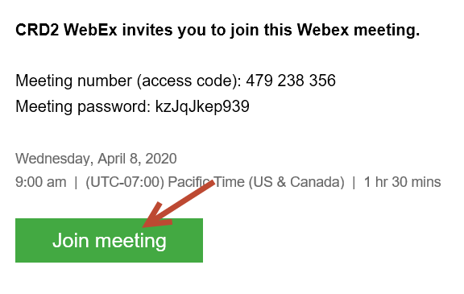
This will take you through the steps you would typically encounter when joining a WebEx. You will then need to connect to the WebEx, so you can be seen and heard.

Step 2: Connecting to the WebEx Audio
Option 1: If you have a good quality headset connected to your computer, you can choose Use computer for audio.
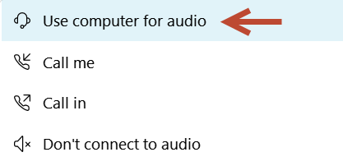
Important: Do not choose this option if you do not have a headset connected to your laptop. Using the laptop’s built in microphone and speakers can cause sound issues during the WebEx Hearing.

Option 2: If you want to use your phone for audio, choose Call me at and enter your phone number. WebEx will then call you and when you answer, you will be instructed to press 1 to connect your phone to the WebEx audio.
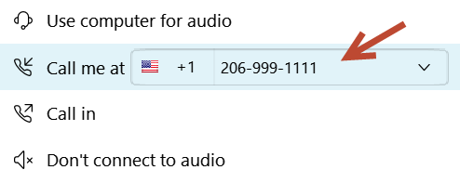

After completing option 1 or 2 (not both), you will be connected to the WebEx Hearing. Once connected, you should verify the host can hear you and that you can hear them. You can then mute your audio and video if necessary, using the WebEx Controls (see step 3).

Step 3: Using the Controls Within the WebEx Hearing
During the WebEx Hearing, you will see buttons at the bottom of the computer screen (if you don’t see these buttons, moving your cursor near the bottom of the screen will cause them to appear):
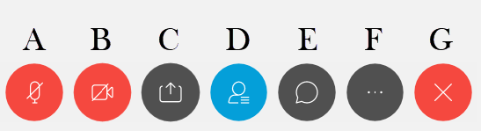

Button Functions:
- Mute/unmute your microphone.
- Turn on/off your video camera. (you should verify that your video is not being shown, unless the court requests to see you).
- Share content (ignore)
- Opens/closes the participants panel
- Opens/closes the chat panel
- More options (ignore)
- Leave meeting

TIPS
- Verify your audio upon entering a hearing, then mute yourself
- Turn off your video when you enter the hearing
- If you might be participating by video, keep any background backlighting to a minimum (No bright windows or overhead lighting)
- Remove pets and other distractions from the room you are in
- Make sure your local network is free of streaming and any other large bandwidth consumption
- Treat the virtual hearing like the physical hearing when interrupting (make sure you are not muted)
- Refrain from eating during the session
- Dress appropriately

FAQs
Can I connect to a WebEx without a computer?
Yes, you can connect your phone by dialing the number and access code provided in the meeting invitation you received. When you do this, you will not be identified to the other participants and will need to identify yourself as a call in participant to the host, once you connect.
Can I use my cell phone for the call?
Yes. It is important, however, to ensure the phone’s microphone doesn’t pick up the sound from the computer’s speakers by muting the sound on your laptop.
Why can’t I be heard even though I tested successfully at the beginning of the Hearing?
You may have muted the sound using the WebEx Control and you have also muted your phone. You will need to unmute both in order to be heard.
Can I forward the invite to another member of my team or staff?
Yes, if someone else needs to take your place, you can forward the invite (you will find Forward on the Meeting tab of the ribbon in Outlook)
Is the public able to participate?
Yes, by phone only. The public should not be given the WebEx invitation. The phone numbers for public access to the hearing are posted on the District Court website: https://www.wawd.uscourts.gov/court-calendar/telephone-conferences.
How do I show a video or send an audio recording?
It is preferred that any audio or video is sent ahead of time to the court for reviewing.
Can I stop the video from switching to whoever is speaking?
Yes, you can change the layout using the icon in the top right of the main video, or you can lock in a video by using the pin icon at the top middle of the main video.

